**Princeton-Humboldt Workshop Schedule**

**December 5th – 8th 2014**

What follows is the agenda of the meeting followed by detailed information on directions and other logistics.

**Agenda**

**Dec. 5th Lecture Hall of Leibniz-Institute of Freshwater Ecology and Inland Fisheries in Friedrichshagen**

Location: Müggelseedamm 310 (not 301) - direction go to S Bahnhof Friedrichshagen, then take TRAM 60 to final destination (only runs every 20 minutes), then 10 minute walk.

**Introduction to Grant, Presentation of Labs of PIs and Get to Know Each Other**

30 participants

**9am to 5pm**

**Project Rationale, Workshop Plan and Lab Introductions**

9:00 – 9:30 *Robert Arlinghaus*: Princeton-Humboldt Reality Mining Centre: Overview, Grant Objectives and Workshop Plan (including brief verbal introductions of all in the group)

**Decision-making & Collective Motion (Princeton speakers)**

09:30 – 09:40 *Iain Couzin*: Introduction to Lab

09:40 – 09:50 *Ariana Strandburg-Peshkin (IC)*: Collective movement in wild baboon

09:50 – 10:00 *Albert Kao (IC):* The robustness of animal collective wisdom in complex environments

10:00 – 10:10 *Colin Twomey (IC)*: Behavioral decision rules from large movement time series applied to schooling fish

10:10 – 10:20 *Matts Grobis (IC):* Information flow under predation risk

10:20 – 10:30 *Katie Fitch* on behalf of Naomi Leonard: Introduction to lab - Models and methods for studying collective dynamics

10:30 – 11:00 ***Coffee Break***

11:00 – 11:10 *Katie Fitch (NL)* Joint centrality distinguishes optimal leaders in noisy networks

11:10 – 11:20 *Will Scott (NL)* Dynamics of pursuit and evasion in a heterogeneous herd

**Coupled Natural-Human Systems (Princeton speakers)**

11:20 -11:30 *Emma Fuller (SL)*: Introduction of the Levin lab on NSF CNH grant using high resolution data on commercial fishermen, ABMs

11:30 – 11:40 *Jennifer Schieltz (DIR)*: Current work in the Dan Rubenstein lab on herders' decision making, livestock, and wildlife

11:40 – 11:50 *Frants Jensen (SL, IC, DIR)*: Coordination and leadership dynamics for marine mammals (Delphinids in particular)

11:50 – 13:30 *Lunch Break and for interested people tour through IGB from 12:30 – 13:30*

13:30 – 14:30 *Discussion*

15:00 – 16:00 ***Iain Couzin’s IGB Public Lecture:* Sensory networks and distributed cognition in schooling fish**

16:00 – 17:00 *Discussion continued*

About 17:00 Leave IGB by bus to holiday party

**Dec. 6th IRI THESYs (Integrative Research Institute for the Transformation of Human-Environment Systems within Humboldt-Universität zu Berlin)**

**Location: Quartier Stadtmitte, Friedrichstrasse 191 in Berlin-Mitte, 4th floor, room 4088**

**Reality Mining of Fishes in the Wild and Animal-Human Systems**

28 participants (with Dan Rubenstein)

**10am to 6pm**

10:00 – 10:05 *Robert Arlinghaus* – Summary of Day 1

10:05 – 10:15 *Robert Arlinghaus*: Introduction to the Lab

10:15 – 10:35 *Shin Nakayama* (RA): Mining the reality of an aquatic top piscivore (the Eurasian perch) in the wild

10:35 – 10:55 *Chris Monk* (RA): Experimental studies on the foraging reality of fishes and vulnerability to angling in their natural environment

10:55 – 11:05 *Pep Alós* (RA): Reality mining of fish-fisher interactions in a coastal fishery

11:05 – 11:30 Coffee break

**Decision-Making and Adaptive Behavior (IDG/Princeton speakers)**

11:30 – 11.40 *Wolfgang Giese* and *Max Flöttmann (lab of Edda Klipp)*: Modelling space use applied to fish

11:40 – 11:50 *Jens Krause*: Overview of lab

11:50 – 12:00 *Dirk Brockmann*: Overview of lab

12.00 – 12:10 *Chen Li* (DB): Preliminary finding on movement patterns of fishes in the wild

12:10 – 12:20 *Dan Rubenstein*: Overview of zebra movement, networks, population dynamics and conservation

12:20 – 12:30 *Verena Hafner*: Overview of models and methods in robotics and adaptive systems

12:30 – 12:40 *Lutz-Schimansky Geier*: Simulation methods of active units

12:40 – 13:45 **Lunch Break**

13:45 – 14:45 **General Discussion** with the Aim to Identify the Top 3-4 Research Questions in Reality Mining of Animal and Animal-Human Systems

14:45 – 15:45 **Break Out** Groups to Identify Teams of Princeton-Humboldt scholar that may be able to collaborate on concrete projects to contribute answers to the previously identified top questions (collaboration through conceptualization, data or methods)

15:45 – 16:15 **Coffee Break**

16:15 – 18:00 **Further Discussion,** **Collective Synthesis and Next Steps**

19:30 Dinner in Berlin-Mitte in “12 Apostel”

**December 7th Individualized Sightseeing in Berlin**

**Dec. 8th Leibniz-Geschäftsstelle in Berlin-Mitte**

**Chausseestrasse 111, U Bahnhof Naturkundemuseum, next to Hotel Mercure, room 1.15**

**Collective decision making in animal groups**

**9am to 5pm** (focused on Krause and Couzin labs) - details to be determined during workshop

**Tentative Agenda**

10:00 – 12:00 Visit of Robofish of Krause lab at Humboldt-Universität zu Berlin, Philippstrasse 13, Haus 16

12:00 – 13:00 Lunch in Mensa

13:00 – 14:30 Talks and Discussion (e.g., George Hagstrom indicated interested in presenting a project he just joined)

14:30 – 17:00 Wrap Up Discussion and Work plan

**Directions and other logistics**

# Arrival and Accomodation

## Hotel

**Mercure Hotel Berlin City**

Invalidenstrasse 38  
10115 BERLIN

Tel.: (+49) 30 / 308 260

Email: [h5341@accor.com](mailto:h5341@accor.com)  
GPS: N 52° 31' 48.86'' E 13° 22' 54.78''

Check-in: from 15:00

Check-out: latest 12:00

## General Information on the public transport tickets:

Please note the following fares:

* One-way ticket 2.60€ (valid for 2h after stamping, not valid to go back or in circles, but you can interrupt your trip)
* One-day ticket 6.70€ (valid for the whole day, until 03:00am of the next day)
* 48h– or 72h-tourist ticket (48h or 72h valid after stamping, check <http://www.s-bahn-berlin.de/en/tickets-fares/tourist-tickets>) usually the 48h ticket is worth when buying it in the evening, otherwise 2 one-day tickets should do.
* Short-distance ticket 1.50€ (counts for 3 stops with U and S-Bahn, changing vehicles is possible; or counts for 6 stops with the bus or tram, but here changing the vehicle is not possible)

At the end of the document, there are some exemplary train connections that would get you to the workshop in time (check [www.bvg.de](http://www.bvg.de) for further connections). You will find alternative routes which you may take.

## From Tegel Airport to Mercure Hotel

Price for a One-way ticket: 2.60€ - can be purchased from the bus driver. If you buy single tickets in the machines, you have to stamp them after you entered the bus.

After you picked up your luggage, please follow the  sign and exit the airport building. Take **Bus128**  direction U Osloer Straße (Fig. 1). At **Kurt-Schumacher-Platz** change to the underground  **U6** direction U Alt-Mariendorf. Leave the U-Bahn at **Naturkundemuseum.** Preferably continue walking in train direction and go upstairs. Turn to the right, cross the street and proceed to follow **Invalidenstraße** (Fig. 2)**.** After 50 meters you will see the Mercure Hotel on your right-hand side.

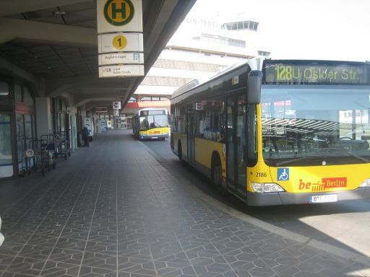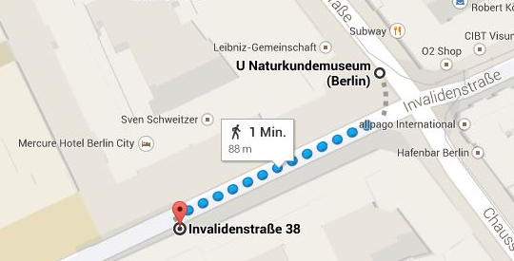

**Fig. 1:** Bus 128, direction U Osloer Str. **Fig. 2:** Walk to the hotel from Naturkundemuseum

### December 5th

## From Mercure Hotel to Leibniz-Institute of Freshwater Ecology and Inland Fisheries in Friedrichshagen (IGB)

Price for a One-way ticket 2.60€. May be bought at the machines. Please stamp single tickets BEFORE you enter the U-Bahn. In case you start your journey in a bus or tram, stamp it inside the vehicles.

Leave the hotel to the left and walk to **U** **Naturkundemuseum.** Take the U6 direction

Alt-Mariendorf. Leave the train at **Friedrichstraße** and follow the S-Bahn sign  to find your way to the platforms of  **and** **.** You may take either of these trains in **EAST** direction, i.e. Ahrensfelde, Straußberg Nord or Wartenberg. Leave the train at **Ostkreuz** and change to  direction Erkner or Friedrichshagen. (For this you have to go upstairs, walk to the other end of the station and go downstairs to the platform of the .)

Try to be in the front part of the train. Leave the  in **Friedrichshagen** and continue walking in train direction. Head downstairs, leave the hall to the **right** and continue to the **second traffic lights.** Cross the street and continue walking to the tram station (approximately 50meters). Enter tram  **60** direction **Altes Wasserwerk**. Leave at the final destination **Altes Wasserwerk.** Walk in opposite direction of the standing train and directly turn left around the corner (see Fig. 3). Continue for like 500meters (you may change to the other side in the meanwhile) until you reach the IGB at **Müggelseedamm 310.**

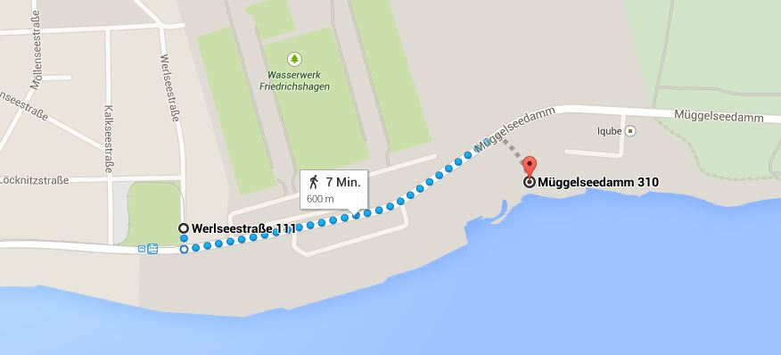

**Fig. 3:** Walk to IGB at Müggelseedamm 310

## From IGB to Christmas Party in Püttbaude (in Berlin-Rahnsdorf)

**Address:**

**Gaststätte Püttbaude**

Hohenberger Steig 23

12589 Berlin-Rahnsdorf

Important: Be prepared to pay cash! The restaurant does not accept credit cards!

The party starts around 18:00. There will be a shuttle to bring you to the restaurant **directly** from IGB. After the party some colleagues will go back to the city center via public transport. Take the chance and get a guided trip back to OSTKREUZ.

There you should take the  **or**  **(**direction **Potsdam Hbf** or **Spandau** or **Westkreuz)** back to **Friedrichstraße.** Change to the underground  **U6** direction U Alt Tegel. Leave at **Naturkundemuseum.** Try to find the hotel (Fig. 2)

### December 6th

## From Mercure Hotel to IRI THESys

Please take the  U6 direction Alt-Mariendorf and leave at **Stadtmitte**. Exit the underground and look for the following **address:**

Friedrichstraße 191 (“Quartier Stadtmitte”), 10117 Berlin

Please note that it is a huge building (Fig. 4) and that you should use the main entrance at Friedrichstraße. Please take the elevator to floor 4 where the workshop will take place. Exact room numbers will be announced later. (Probably conference **room 4088**).

<https://www.iri-thesys.org/contact>

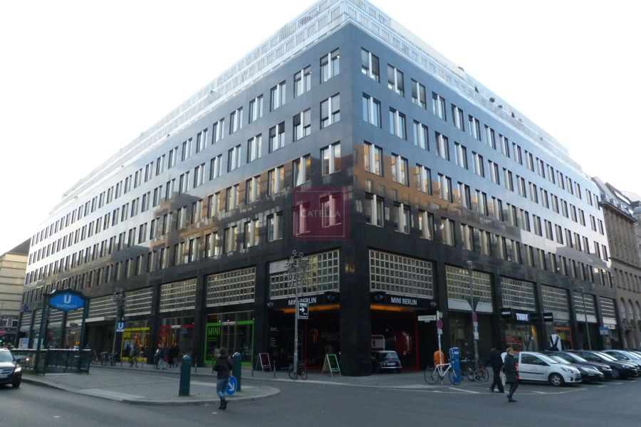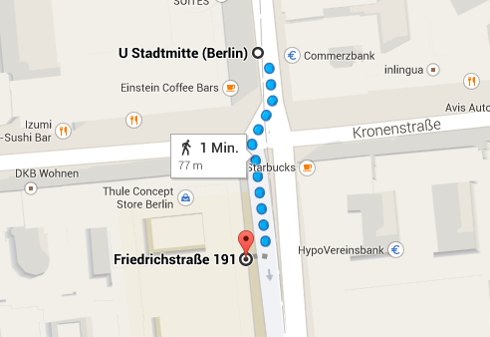

**Fig. 4:** Quartier Stadtmitte, Friedrichstraße 191 **Fig. 5:** Walk to Friedrichstraße 191

Note: after the workshop, there is dinner in 12 Apostel (see below). If you want to go back to the hotel first:

## From IRI THEsys to Mercure Hotel

Take the underground  **U6** direction Alt Tegel. Leave at **Naturkundemuseum.** Go upstairs and look for the hotel (Fig. 2).

## Dinner at “12 Apostel” (19:30 after the workshop)

**Address:**  
Georgenstraße 2

10117 Berlin

S-Bahnbögen 177-180

<http://www.12-apostel.de/en/location.html>

Important: Be prepared to pay cash! The restaurant does not accept credit cards!

1. From Mercure Hotel to Restaurant

**12 Apostel**

Leave the hotel, go to the station **Naturkundemuseum** and take the underground  **U6** direction U Alt-Mariendorf. Leave the U-Bahn at **Friedrichstraße.** Go upstairs and leave the building. Cross the big street (Friedrichstraße) and proceed to follow **Georgenstraße** direction east (Fig. 5). That is the street with cobblestones. The restaurant should be located on the left side.

**From IRI THEsys to Restaurant 12 Apostel**

In case you are coming directly from IRI THEsys, please take the underground  **U6** direction Alt Tegel. Leave at **Friedrichstraße.** Go upstairs and leave the building. Cross the big street (Friedrichstraße) and proceed to follow **Georgenstraße** direction east (Fig. 5). That is the street with cobblestones. The restaurant should be located on the left side.

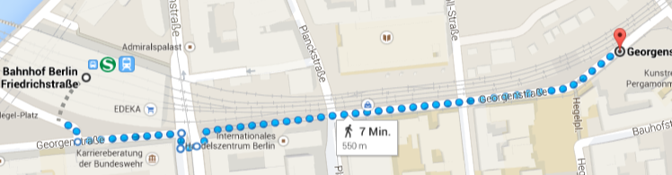**Fig. 5:** Walk from Friedrichstraße to the restaurant 12 Apostel

## From Restaurant to Hotel Mercure

Walk back to Friedrichstraße (Fig. 5), go downstairs to the underground  **U6.** Take the train direction Alt Tegel. Leave the U-Bahn at **Naturkundemuseum.** Look for the hotel (Fig. 2).

### December 8th

## From Mercure Hotel to Leibniz-Geschäftsstelle

Address: Chausseestraße 111, room 1.15

Go out of the hotel, direction U Naturkundemuseum (Fig. 6). Enter the building of the **Leibniz Gemeinschaft** close to the corner (Fig. 7), the entrance is actually in the same street as the Hotel Mercure.

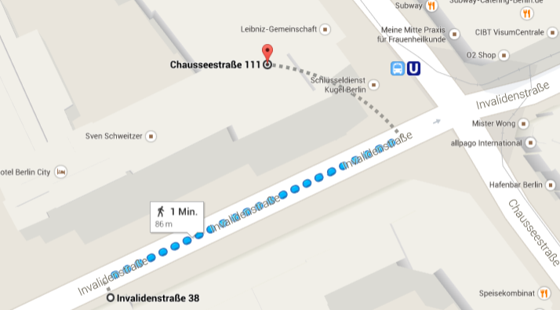

**Fig. 6:** Walk from Hotel Mercure to Chausseestraße 111

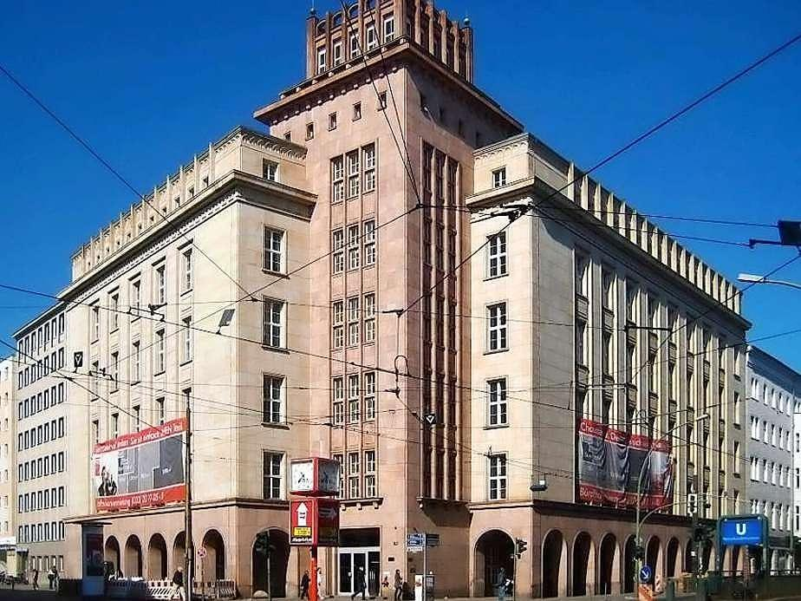

**Fig. 7:** Leibniz-Geschäftsstelle entrance

# Exemplary train connections

(check [www.bvg.de](http://www.bvg.de) )

**From Tegel Airport to Naturkundemuseum**

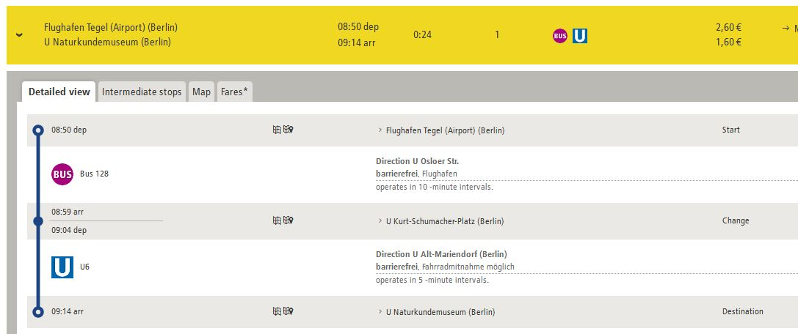

**From Naturkundemuseum to Altes Wasserwerk (IGB)**

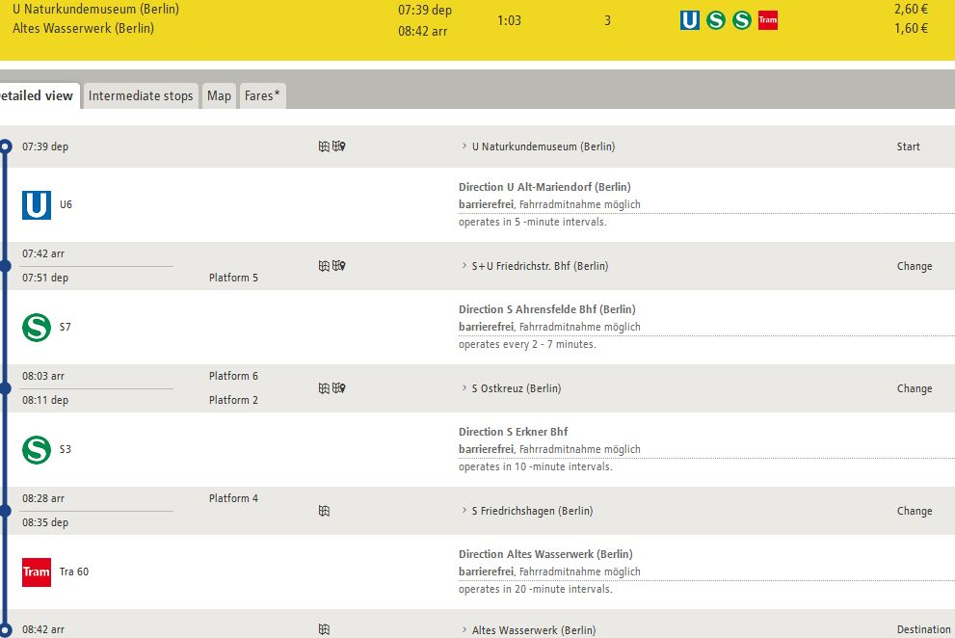

**From Mercure Hotel to IRI THESys (Friedrichstraße 191, 10117 Berlin)**

